**Measurement Model**

**Q1) What are the constructs in this scenario?** (provide your answer in text format)

In this scenario our constructs is the wine quality. Experts assess wine production and chemical composition, considering factors like fragrance, flavor, and color, as well as grape type, environmental conditions, fermentation strains, and viticulture practices.

**Q2) What is the key latent variable to measure? What are the indicators? (text and graphics)**

The key latent variable on this scenario is the wine quality. Wine quality is a subjective and complex concept that is influenced by a variety of elements, including its chemical makeup, its sensory qualities, and the opinions of experts. The indicators are chemical composition (flavor, color, chemical components), sensory characteristics, the evaluations from experts (ex. Ratings) and the machine learning models predictions. So, the graphics are:

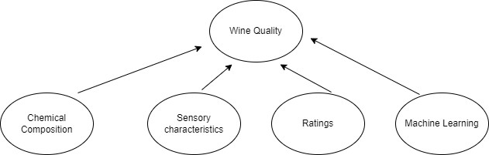

**Q3) Are the indicators in your model causal or effect? Why? (text)**

In this article, the indicators of wine quality are both casual and effect. For example, the chemical composition and sensory characteristics are casual effects because influence the latent variable (wine quality). The values of these characteristics can influence with different way the wine quality. However, the ratings from experts and the machine learning models are the effect indicators since the wine quality drives the indicators. Several factors, such as the chemical composition and sensory qualities, affect the evaluations. Machine learning models' predictions are outcomes that are impacted by the chemical and sensory characteristics of the wine that they were trained on.

**Q4) Are the indicators continuous or discrete? Is the latent variable continuous or discrete? Why? (text)**

The chemical composition can be both continuous and discrete according to the values the these variable have. For example, the flavor is continuous and 4-ethyl-2-methoxyphenol is discrete. Also, the same exist on sensory characteristics, the softness can be continuous but the black glass and be discrete. On the other hand the assessments from experts and the machine learning models results are continuous due to the numerical scales and levels. The wine quality is continuous because it represents a range of wine qualities, with values from low to high.

**Q5) What instruments are used to measure the indicators? How would you evaluate their reliability and validity? (text)**

Laboratory instruments like gas chromatography, mass spectrometry, and spectrophotometry analyze wine's chemical composition. Reliability is assessed through calibration, precision testing, and consistency, while validity refers to the accuracy of these instruments in measuring specific components.

Sensory evaluations can be assessed using trained panels or expert evaluators using standardized techniques. Reliability is enhanced through rigorous training, calibration, and consistency checks. Validity is ensured through validated sensory descriptors, reference standards, and statistical analyses.

Expert evaluations often use rating scales or scoring sheets, ensuring inter-rater reliability through training and calibration exercises. Validity in these evaluations relies on expert expertise and accurate representation of wine quality, supported by sensory and chemical analyses.

Machine learning algorithms like SVM, RF, and AdaBoost predict wine quality based on input features. Reliability is evaluated through metrics like accuracy, precision, recall, and F1 score, while validity involves models accurately reflecting data patterns.

**Q6) How would you define mathematically an appropriate measurement model? (text and math)**

A measurement model is a formal mathematical relationship between a latent variable or set of variables and an observable variable or set of variables. Confirmatory Factor Analysis (CFA) is a methodology commonly used in research and still papers to confirm the factor structure of observed variables.

**Math Model:**  xij​=λij​η+εij + a

* *xij*​*: indicator*
* *λij: factor loading coefficient*
* *εij: random error*
* *a intercept*
* *η: latent variable*

*\*  (i equals to number of constructs, j the value of each construct)*

**Predictive Modeling**

Predictive modeling is a commonly used statistical technique to predict future behavior. Predictive modeling solutions are a form of data-mining technology that works by analyzing historical and current data and generating a model to help predict future outcomes. Classification is a process related to [categorization](https://en.wikipedia.org/wiki/Categorization), the process in which ideas and objects are recognized, differentiated and understood. Classification is the grouping of related facts into classes. It may also refer to a process which brings together like things and separates unlike things. In this case, the model tries to classify a sample into one of several possible classes. For example, in our case wine quality is taking 3 different values like levels 1,2,3, categorize how good is the quality of the wine.